City Commissioners  Daniel F. Aussem  Public Property  Wayne A. Eichelkraut. Jr.  Accounts & Finance  Edward V. Whitney  Public Health & Safety  Dale F. Baxter  Streets & Public Improvements | ROBERT M. ESCHBACH  MAYOR  301 W. MADISON STREET, OTTAWA, ILLINOIS 61350  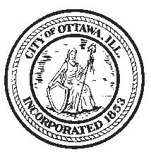 | Pool, Leigh & Kopko  Corporation Counsel  Donald J. Harris  City Treasurer  David A. Noble  City Engineer  Shelly L. Munks  City Clerk  Phone: 815-433-0161  Fax: 815-433-2270 www.cityofottawa.org

Public Notice

Commissioner Eichelkraut has announced that the City Of Ottawa, North Central Area Transit (NCAT), will be hosting an informational public meeting on reconvening the Advisory Committee. The meeting will be held at the City Hall, in the council chambers, 301 W Madison St, Ottawa, IL on September 24, 2018 at 10:00 AM. Anyone interested in improving public transportation in La Salle County is welcomed to join.

Alaina Rivers
Deputy City Clerk
City of Ottawa
301 W Madison St
Ottawa, IL 61350
815-433-0161 ext.123

